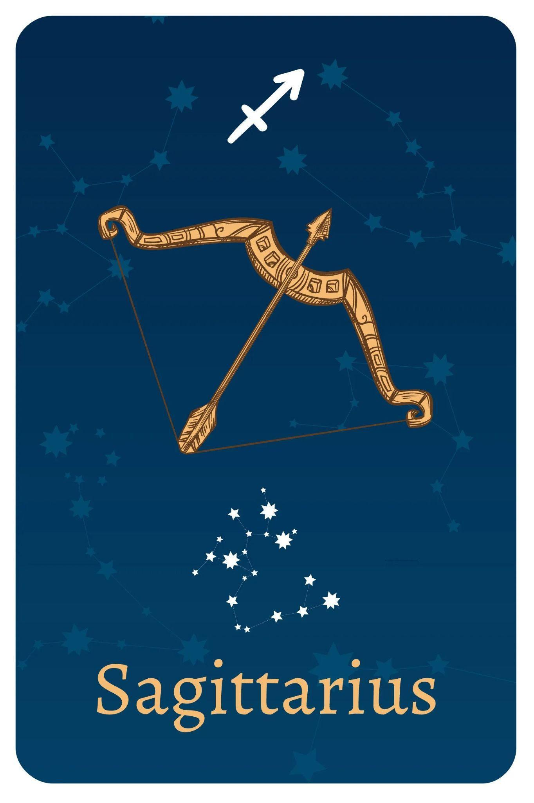

TEAM MEMBERS

Shivansh Shukla

Nathan Lee

Edwin Kulakkattolikel

<Insert and refresh table of contents below>

Contents

PURPOSES AND GOALS 3

HOW TO INSTALL THE PROGRAMS 4

DEPENDENCIES 4

HOW TO RUN THE PROGRAMS 4

DESIGN ARCHITECTURE 5

PROCESS & WORKFLOW 5

TEST DATA 5

VIDEO RECORDINGS 6

CONCLUSIONS 6

REFERENCES 6

# PURPOSES AND GOALS

<Tell a brief story why (purposes) you need to do this lab, and what (goals) do you try to achieve. Everything must fit on this page only.>

**Hello World**

The task serves as an introduction to the Spyder IDE, Anaconda Command Shell, and the Python language. This simple task involves printing the text “Hello World”.

**Loan Calculator**

The task involves building a Loan Calculator application with the Python Tkinter module. The goal is to provide an easy-to-use tool that lets users compute monthly loan installments and the total amount paid over the loan duration. This assignment is designed to give students practical experience in creating a Graphical User Interface (GUI) application and to reinforce ideas about computing financial data.

**Shoot The Fruit**

The task serves as an introduction to Python GUI games, actors within the game, and a simple check function to develop the game’s mechanics. The task involves creating a simple game using the pygame packages installed using the pip installer. The game will involve at least three actors, which the creator can choose. The player will be able to click on the assigned target and the game will verify if the target is hit or missed. The game will then move the actors and provide information about the player’s performance of “shooting the fruit”.

**HelloWorldEXE**

The task serves as an introduction to creating an executable file from any Python code. The task involves creating an executable of any Python code, which has been chosen to be a simple hello world file.

**AI Generated Code**

The task serves as an introduction to AI as a source of learning for coding simple tasks. The task involves asking several AI engines to generate Python code to add two numbers.

**Simple Calculator**

This task uses the Tkinter module on Python, which allows the user to do simple calculations with the simple calculator. With this calculator, the user is able to make basic calculations with addition, subtraction, multiplication and division. It is also capable of doing calculations such as square root, squaring, and inverse power. This program is designed and modified with organized layout with good color contrasts.

# HOW TO INSTALL THE PROGRAMS

## DEPENDENCIES

<Describe the dependencies, such as pip installations, use of Windows 11, Chrome browser version, etc.>

**Loan Calculator -** pip install tkinter library if it is not already installed on the system using “pip install tk”

**Shoot The Fruit -** pip install pygame, pgzero

**HelloWorldEXE -** Run “pyinstaller --onefile pythonScriptName.py” code in the command prompt.

**Simple Calculator -** pip install tkinter

# HOW TO RUN THE PROGRAMS

<For example, how a user play the game that you developed>

**Hello World**

Ensure Python and any preferred IDE are installed onto the device. Run the file through the preferred Integrated Development Environment (IDE).

**Loan Calculator**

To initiate the LoanCalculator program, verify the presence of Python on your system. Incorporate the LoanCalculator.py file within an Integrated Development Environment (IDE) or employ the terminal by dragging the file into the interface. Execute the program using the command "python {filename.py}" in the terminal. A graphical interface comes up, ushering in the Loan Calculator tool. Input pertinent loan details, activate the "compute payment" function, and witness the GUI deliver essential financial metrics including monthly payments, cumulative payments, and interest paid.

**Shoot The Fruit**

To initiate the ShootTheFruit program, ensure pygames and pgzero are installed. Run the code the code on preferred IDE. The game will load as another program window. Clicking within the window will register as a shot. Shooting the normal apple, which is the intended target will return with a good shot response and the hit counter in the top left corner will increase. Shooting the apple with a worm in it, a rotten apple, or any other part of the window will result in a miss.

**HelloWorldEXE**

The HelloWorldEXE.exe file may be run by clicking the file in File Explorer or made into a shortcut on the desktop. After the file is run, an empty prompt window will run and will then run the executable. Clicking the Click Me box of the executable will return revealing the text Hello World

**AI Generated Code**

The program can be run through any preferred IDE and will prompt the user to input a first number into the console. After the first number is entered, the program will prompt the user to input a second number. After the second number is entered, the program will return with the sum of the two numbers.

**Simple Calculator**

In order to run the program, Python version 3 should be installed on the device. Once installed, the SimpleCalculator.py can run by clicking on the file. Once the file has been opened, the program will start running and can be used.

# DESIGN ARCHITECTURE

<Describe at the high level how the hardware and software logical blocks are related together. A hardware block may contain several software components that depend on one another. Many hardware blocks can link together. Blocks can be local and on the cloud.>

**Loan Calculator -** The code interacts with local hardware resources like the screen while using software components for the GUI, loan calculation, and event management. User interaction is made possible by the GUI being shown on the hardware's screen. Functionality could be increased by using cloud-based components. This synergy demonstrates how smoothly local software and hardware pieces interact with one another.  
  
**ShootTheFruit -** The code displays a Pygame Zero-created game in which logical building blocks, such as game logic, graphics rendering, and input/output management, communicate with hardware and software elements such as the display, mouse, and the Pygame Zero library. These building elements work together to create behavior, control visuals, and handle user interactions. Events that update hit/miss statistics, move actors, and display messages are started by mouse clicks. Although the game is local, current systems might include cloud-based components for items like multiplayer or leaderboards, although this is not immediately clear from the code.

**HelloWorldEXE -** The provided code establishes a logical connection between hardware, display and mouse, software components, Tkinter library, and Python script, by developing a graphical user interface (GUI) application. The window's appearance is determined by the GUI setup, and user input is handled by event handling. The components of the GUI are coordinated by interaction management. The GUI uses the hardware resources to show the window, respond to user clicks, and refresh the interface while running as an executable application.

# PROCESS & WORKFLOW

<Describe the process and workflow. One example of the process of filling a car gas tank is for the user to swipe the credit card, then wait for the credit card approval, then select the gas pump number, and begin to fuel up, then hang up the gas handle, and exit the gas station. One example of the workflow is for the user to get in line at the gas station, wait for his/her turn and drive up to the pump, follow the pump instructions to pay and pump, then exit the station safely.>

**Loan Calculator -** Users enter loan information into a Loan Calculator GUI that is created by the code using Tkinter. The user enters information in the fields and then clicks "Compute Payment," which starts an event-driven calculation and displays the results on the GUI. The procedure includes starting the software, entering loan details, calling the computation, and getting results within the GUI interface. By using an iterative procedure, users may easily generate loan metrics.

**ShootTheFruit -** The user will click on the application window to shoot. Shooting the normal apple will prompt the application to move the normal apple, print Good Shot into the console, and increase the Hit counter. Shooting the worm apple, rotten apple, or any other part of the screen not including the normal apple will prompt the application to move either the worm apple or rotten apple at random, print Missed! in the console, and increase the miss counter.

**HelloWorldEXE -** The user will click on the application file and see the GUI with the Click Me box. The user will click the box and see the Hello World text.

**AI Generated Code -** Open any preferred AI Chat/Prompt Generator. Enter prompt clearly stating wanted information. Addend or adjust questions to further improve response.

# 

# TEST DATA

<Only applicable for labs that need testing. Feel free to leverage the templates here: <https://strongqa.com/qa-portal/testing-docs-templates/test-report>>

**Loan Calculator**

| **Test #** | **Annual % Interest Rate** | **# of years** | **Loan Amount $** | **Code Results** | **Successful** |
| --- | --- | --- | --- | --- | --- |
| 1 | 2 | 2 | 100 |  | yes |
| 2 | 5 | 3 | 1000 |  | yes |
| 3 | 10 | 5 | 10000 |  | yes |

**AI Generated Code**

| **Website** | Prompt Response |
| --- | --- |
| **iAsk.ai** |  |
| **Bard.google.com** |  |
| **you.com** |  |
| **Bing.com** |  |

# VIDEO RECORDINGS

<List all video recording with titles, purpose, and YouTube or Cloud Drive locations. Ensure to enable sharing permissions.>

| **Recording Title** | **URL** | **Notes** |
| --- | --- | --- |
| Lab 1: Loan Calculator Demo | <https://youtu.be/Lb9svidKsx8> | Demonstration for Lab 1 Loan Calculator |
| Lab 1: Hello World Exe | [EE104 - Lab 1: Hello World Exe](https://www.youtube.com/watch?v=-MOXH_rXgl4) | Demonstration for Lab 1 Executable Hello World |
| Lab 1: ShootTheFruit | [EE104 - Lab 1: ShootTheFruit](https://www.youtube.com/watch?v=Sof4Em_2uQo) | Demonstration for Lab 1 Shoot The Fruit Game |

# CONCLUSIONS

<Briefly restate at the high level the purposes of this lab, what your team achieve, and whether it is successful or not, etc.>

<Also state the lesson learned, how can you do it better the next time, with better resource, etc.>

# REFERENCES

* What Is Agile Reporting? (Definition and How To Complete) <https://www.indeed.com/career-advice/career-development/agile-reporting>
* Test Report <https://strongqa.com/qa-portal/testing-docs-templates/test-report>
* <Add your other resources here>

*Bing AI*. (n.d.). Bing. https://www.bing.com/search?form=MY0291&OCID=MY0291&q=Bing+AI&showconv=1

*Built-in Objects — Pygame Zero 1.2.1 documentation*. (n.d.). Pygame-Zero.readthedocs.io. https://pygame-zero.readthedocs.io/en/stable/builtins.html

*Create Executable from Python Script using Pyinstaller - Data to Fish*. (n.d.). Datatofish.com. https://datatofish.com/executable-pyinstaller/

Google. (2023). *Bard*. Bard.google.com. https://bard.google.com/

*iAsk.Ai · write a python code ask for 2 numbers and add them together*. (n.d.). Ask AI. Retrieved August 31, 2023, from https://iask.ai/?mode=question&q=write+a+python+code+ask+for+2+numbers+and+add+them+together

(n.d.). You.com. https://you.com/search?q=write+a+python+code+ask+for+2+numbers+and+add+them+together&fromSearchBar=true&tbm=youchat&cid=c2_0911b993-5ef4-4701-bb5d-19302a438dc2